Executive summary
The business strategy game simulation provides important opportunities to the students while learning especially in the field of the real-world business competitive environment that plays key roles for a good decision making for effective decision making that is so crucial in the field of market. However, in the education setting the use of strategy game simulation is not well specified or not well understood. Therefore, from the experiential learning point of view, as a we managed to come up with the conceptual model that was so essential to examine the perception of the students’ draws from the strategy game simulation that can help them to compete especially in the field of business. From the gathered results of each committed member in our group the data shows that the simulation game have a lot of positive outcomes on the learners skill development, effective evaluation, and conceptual understanding for the learning experience of the students. In this report the main focus is the impact of strategy game simulation findings and its application on the field of education by the students that can be of more beneficial while providing a good research in the future especially in the area of business.
Mission and vision statement
The data provided will help us generate a report that will help us manage and run the BSG Company in an organized manner. Ample time have to be spent looking at the results for the 10 years and generate a comprehensive twenty-page report that will offer one with the ideal information to strategize for the next year.
Year 11 (First Round)
During this year, some of the group members were committed undertaking their roles in this first that led to the higher quality, price reduction and increasing the number of the model leading to the reduction of advertisement more than thrice the average celebrities bidding. At the same time same players went for the private market staking much higher price hoping to go on top. It was so clear to us that by this year 11 we were not aware von what other competitors will do to win. Therefore, will be either we win or we lose but it will be so good to us that we win anyway. When it happens that we lose definitely the share price will go down leading us to buy the shares at the lower price which still okay to us.
To be on top we were able to come up with the three strategies that were different from the others. This area;
- Lower Cost
- Quality
- Number of Models
30 minutes to learn new screen of decision
For the effective coming up with the good decision we had to put our ideas into the screen first before doing anything. To make our business more competitive we did everything which is so different from others to make sure that our strategies are different and they are correct to compete with other competitors, hence putting them in the software. As such the 30 minutes are so enough to us o put our strategies in the screen to make sure that they outlook the others.
However, we took another 30 minutes just to make sure that we read the entire requirement to the best of our understanding. This was to make sure that we have enough information that will enable us to make the necessary decision in the coming years. Since his is the competitive game it is good to come up with the effective strategies to help us to compete to the later to put us on the top of the industry.
We also came up with two objectives;
- To improve the result yearly
- To be on top of the industry
These two objectives were to enable us that our company becomes on top making much profit hence not becoming the bankruptcy after undergoing some few years.
Year 12 to Final Year 20
We were so careful in choosing our strategies which are different from other groups to make sure that we were unique from the rest. When it reaches a point where the two groups sets up the strategies which are the same, they may end up competing stiffly within their market areas. This means that the strategies have to be different from the rest and this was our main objective to put in consideration. Some of this startegies that we put in place are;
- Wide range of models
- High quality of production
- Low price
Since the main focus was all about the multi-national firm the share-holders therefore, are mostly interested in the stock price as compared to the dividends. As a such we put our strategies to make sure that our profits increases yearly for good competing in the game and also for the real industry to effective competing with the competitors.
In the other hand by making sure that the buying of the sold capacity is well put in please helped the save the cost at a higher percentage, and the production of cost only goes down when there is an increase in capacity. To maintain this we were able to stay up late contrary to our competitors so that we can buy their sold capacity. At some point this tricks can be known by other groups.
Since this game went for 10 years, we were able to borrow 10 years loan to help us to build the new industry for the effective competition in the field. Through borrowing can also help us to boost our productions much higher to be on the top of other groups.
What helps us to be the winner?
- Having a larger plant than our opponent in a region
- High number of model numbers
- High outstanding shares of stock than other groups
- Buying of the stocks immediately we started getting the profits
- Start increasing AP factory
- Increasing of capacity yearly
Through several advertisements, low price and high number of models rises the demand of our products which led to the increase of production hence being on top. Our capacities were much available with all the demand in the competitive market that helps us to sold much high. The only thing we make sure was to bring the demand close to us to know what they require which was contrary from other groups.
What to consider
- We considered borrowing at the beginning of the which helps to expand our industry hence building the new one.
- We also considered upgrading our business, this was achieved by having small capacity that reduced the cost of upgrading.
Stock Buying
- By buying back 3.500.000 of 20.000.000 stocks, to improve on ROE and EPS
- Low dividends low, at around $ 0.05 but increase it yearly
Plant Capacity
- We borrowed to start up a new business
Application of the Theory
Being on top of the game is so important that each group is looking at. We were able to achieve this by learning through our failures and those of others. But also we learnt from our strength and that of others. For the easy application of the business strategy we asked ourselves the following questions;
- What are the core competitive advantages?
- What are the niche markets that competitors do not see?
- What is the low cost strategy?
- What is the high quality strategy?
- What is the company differentiation strategy?
- How can the company leads the market, in 10 years?
- How can the company defend the position, if we are leading?
- How can the company over come a tough competitors?
- How can the company jump like a frog over the head of competitors?
- How can we apply the knowledge from Textbooks?
Figure out Your Strategy
This was achieved by
- Having high quality of production
- Low cost of production
- And low pricing
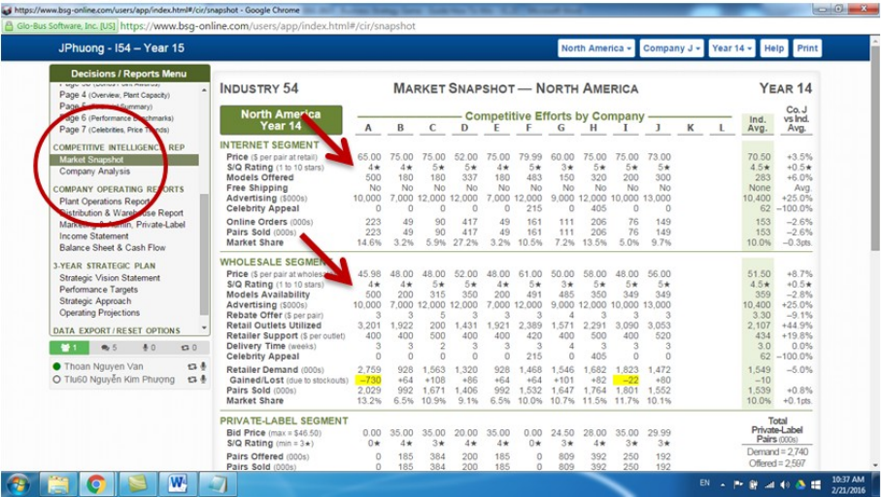
The cost decreases and the profit increases when the cost a point where you want to lower the numbers of production and vice versa.

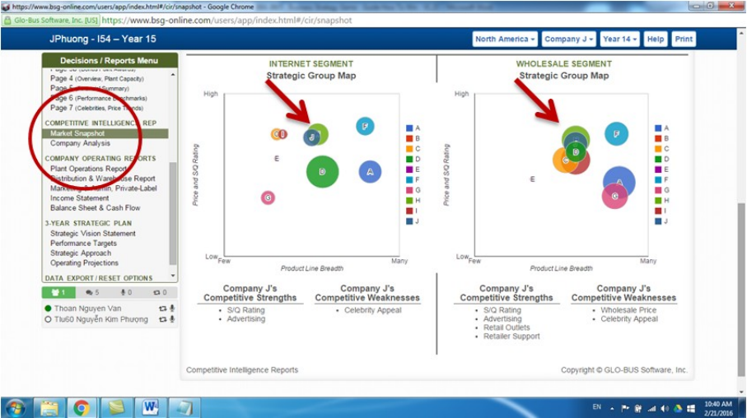
Keeping low cost
This was able to;
- Bring a lot of profit
- Save the cost of production despite high quality of production
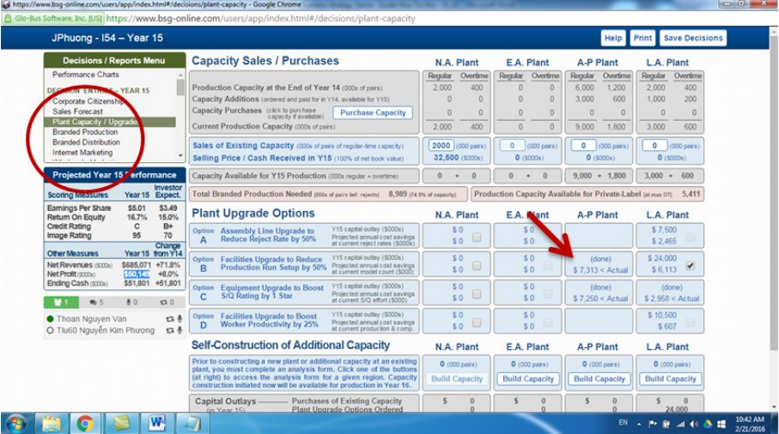
We were able to upgrade the system so that we can get the advantages of long term effects from our plant. We also upgraded the plant as part of our strategy that we put in place to improve our plant. Through this we were able to improve the quality of production and brings several benefits in the following years.
Profit keeping track
We were able to achieve this by;
- Keeping a record of net profit
- Taking note of the record for the accountability
- Workforce and ethics diversity
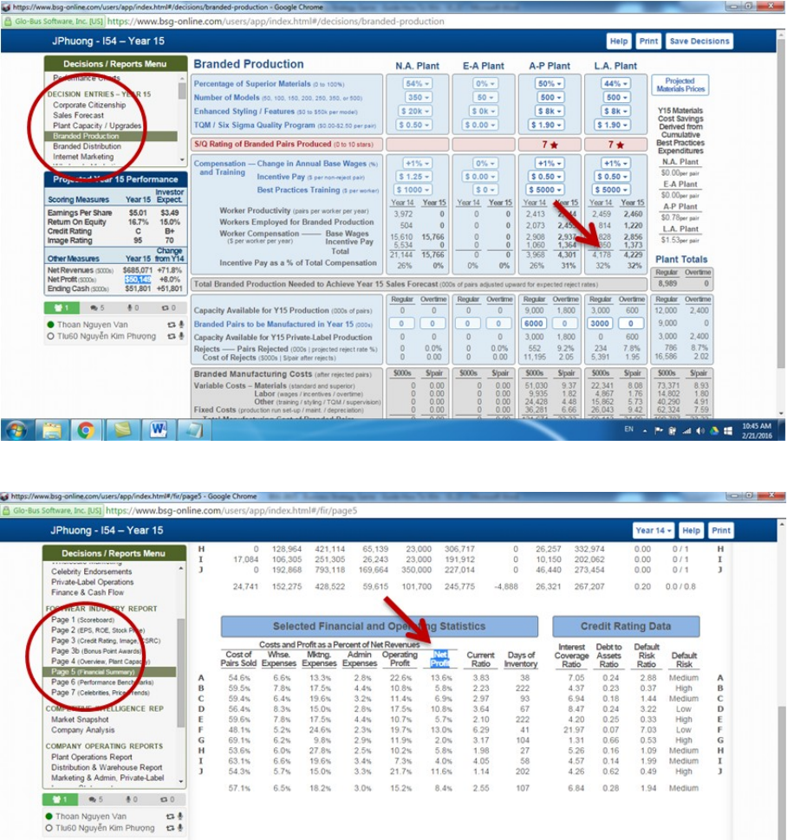
At some point we were able to take profit margin of over 10-15%-20%
Upgrade current factories
Since we went for the higher quality strategies our quality of production was so high that was able to meet in the competitive field.
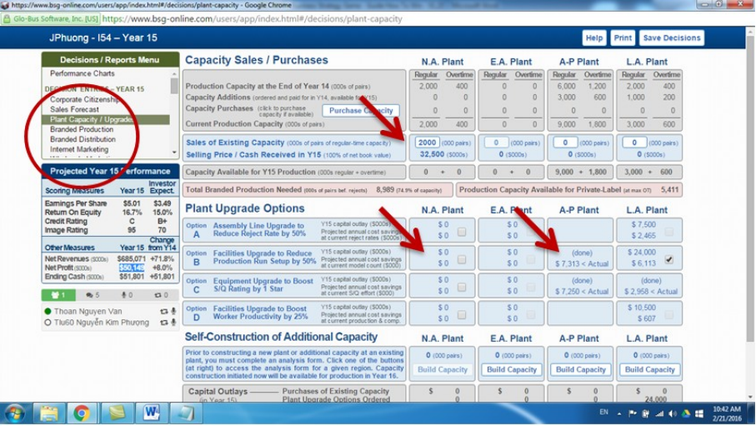
Competitors
To achieve this we were able to know our competitors price that we builds ours from. Even though it is so risky to reduce the price lower than that of our competitor we might run to lose but the good part of that is that we managed to sell more of our products hence high profits.
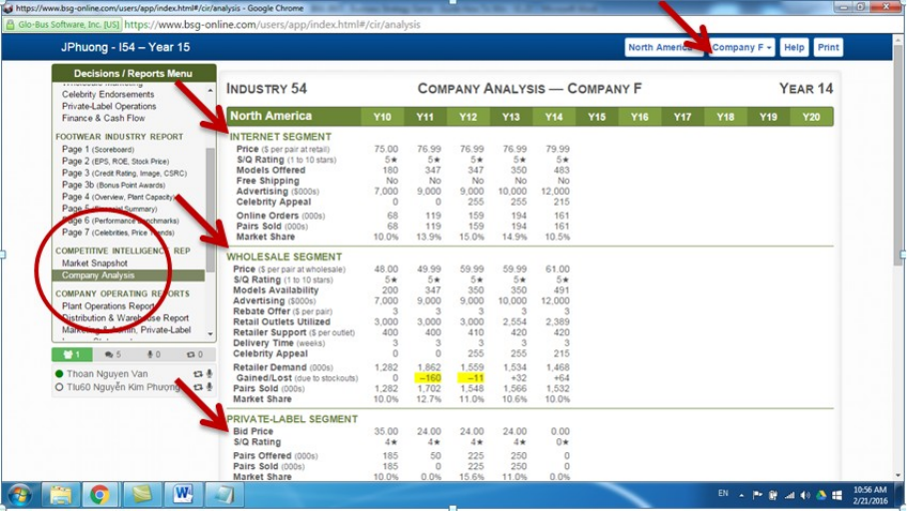
Control the Private Label Market
From our large capacity the production was high that enable us to reduce the cost of product to meet high demand than that of our competitors
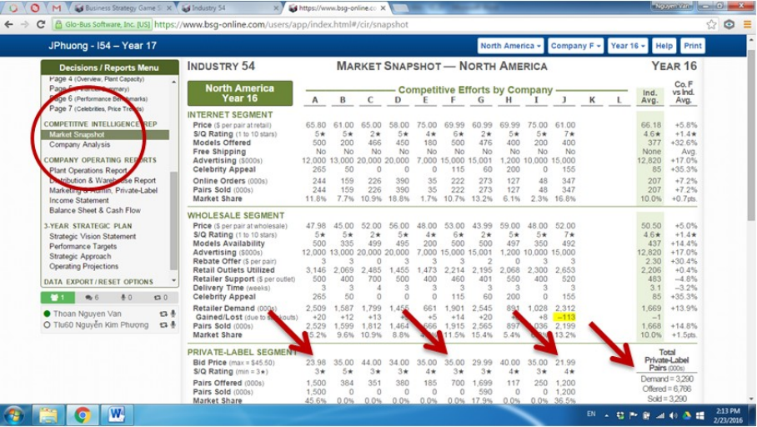
Private-Label Segment and Market Snapshot was our major concern here. We tried to compare from our major competitors who still spend some 600-800 for their bidding due to their little extra-large plant capacities. We always kept the low price that is affordable by every bidders so that we can have a wide market range for our product throughout the period of 10 years.
Focus on a strategy
We were able to win this by;
- Following low number of model and high quality
- Setting mid quality and high number of model
- Focusing much on the profit rather than on the market share
- Were also able to calculate our profit growth yearly
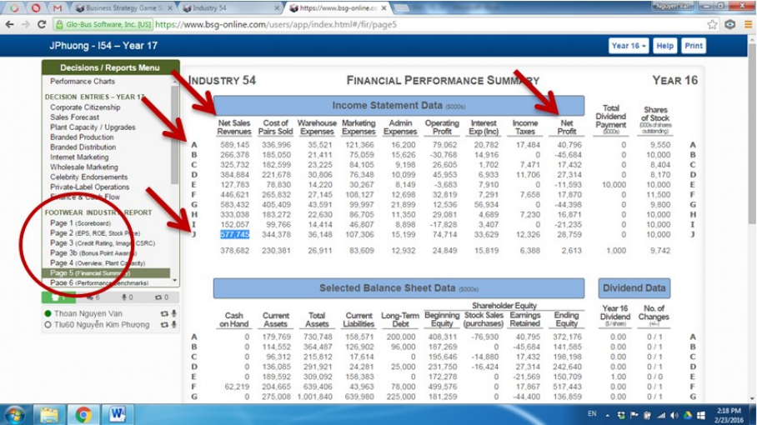
Plant capacity
This is a critical part that we were able to into consideration to make sure that in everything we dealt in in we gets the profit but not the loss. This was achieved by the demand exceeding the supply by a wider margin to make sure that all the products were sold. To maintain our profit level we make sure that we do not sell upgraded factories to avoid running into losses.
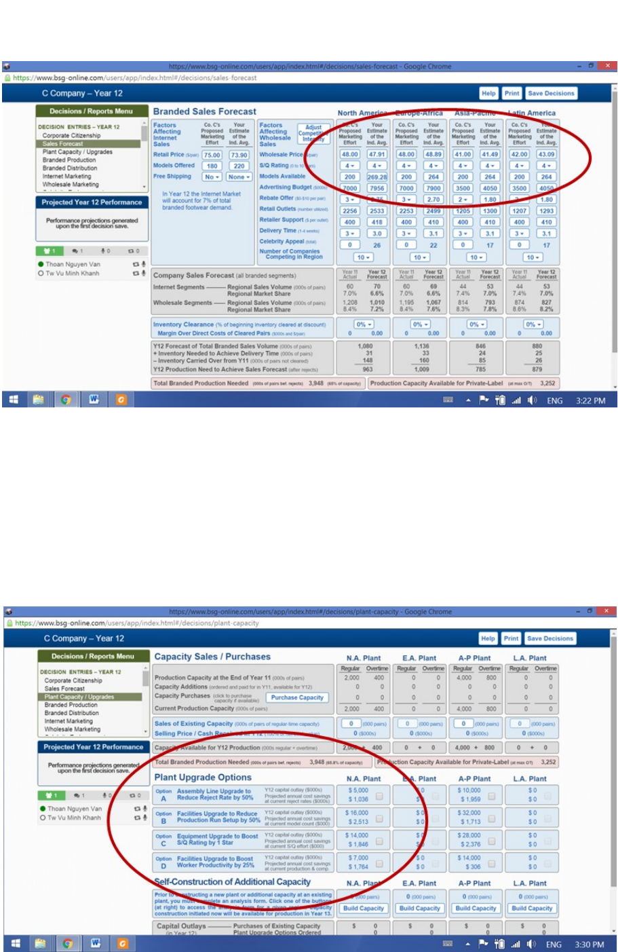
Branded Production
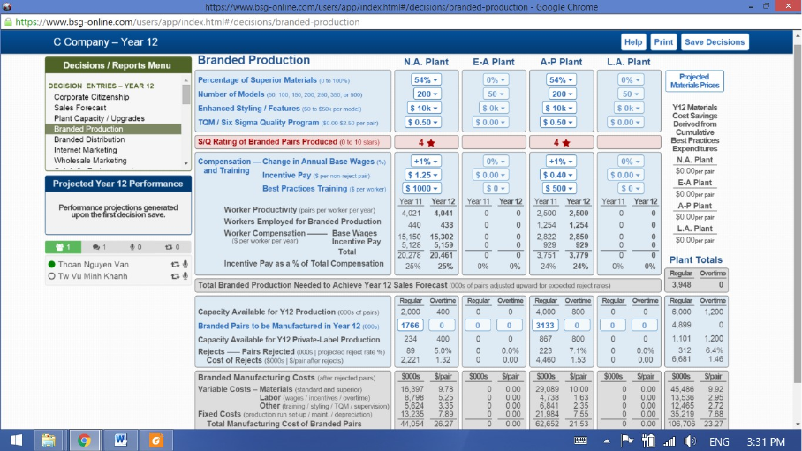
- We were able to get desired quality for our branded products
- We were able to set the best practice training high
- We were able to get higher profit
Finance and Cash Flows
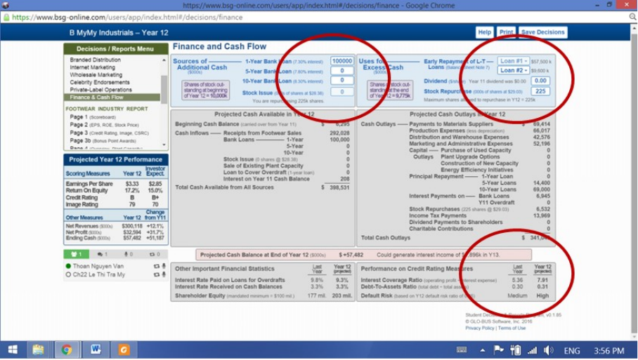
This was so important in our planning of our expenditure. We achieved this by as a group by;
- Checking the interest rates to borrow that is much low
- Stocks issuing
- Buying of back stocks that helps to boost EPS
- Paying small dividends
Details are important 1 – Branded Production
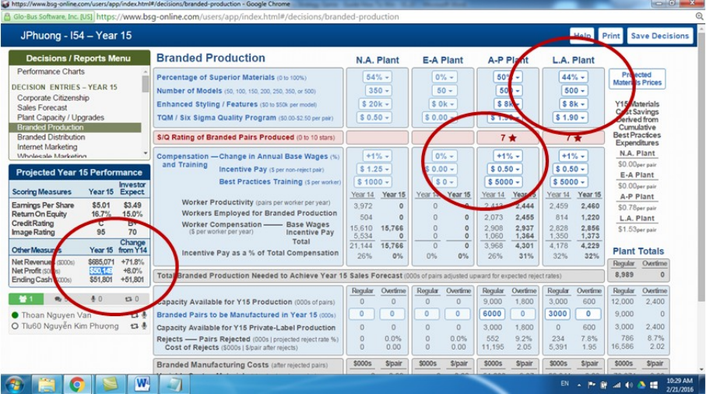
- We were able to make sure that branded production were well kept
- To increase our net profit we make sure that Materials, Styling/Feature and Number of Models, TQM and Best Practice Training were put in place.
How to keep track of Overall Scores
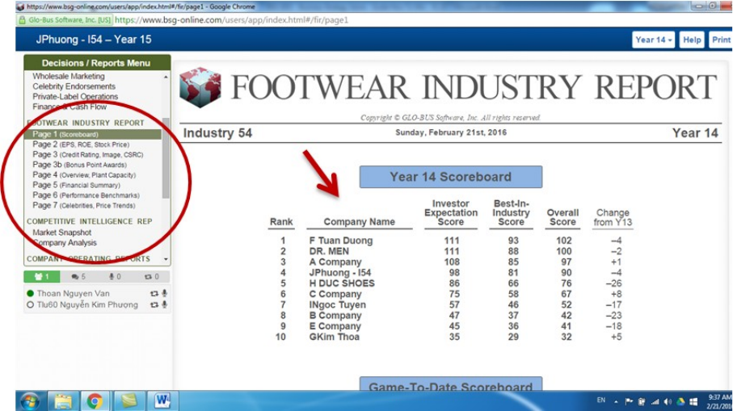
Conclusion
In conclusion, this report has a much impact on the game based learning throughout the empirical evaluation in the education using strategic game. The most important part of this report is how EL has positively impacted much towards the students learning outcomes. From the report it is clear that the learners should actively collaborate for the effective engagement in the game and even the instructor should also participate fully to make sure that the intended decisions and the strategies were achieved fully.

